JUST SIT BACK, AND RELAX.
Welcome to the largest outdoor church in
America. In just a few moments the service will begin so we invite you to find a place in the sunshine or in the shade and sit back and relax in this beautiful part of paradise.

If this is your first time at the park, please fill out your connection card and take it to the information table for a free gift. If you have kids, be sure to pick up a ‘Sunday School In A Bag.’

Please remember that all pets should remain on a leash and to silence your cell phones. And now, it’s time to go to church, get a tan, and change your life!
CELEBRATION NOTES
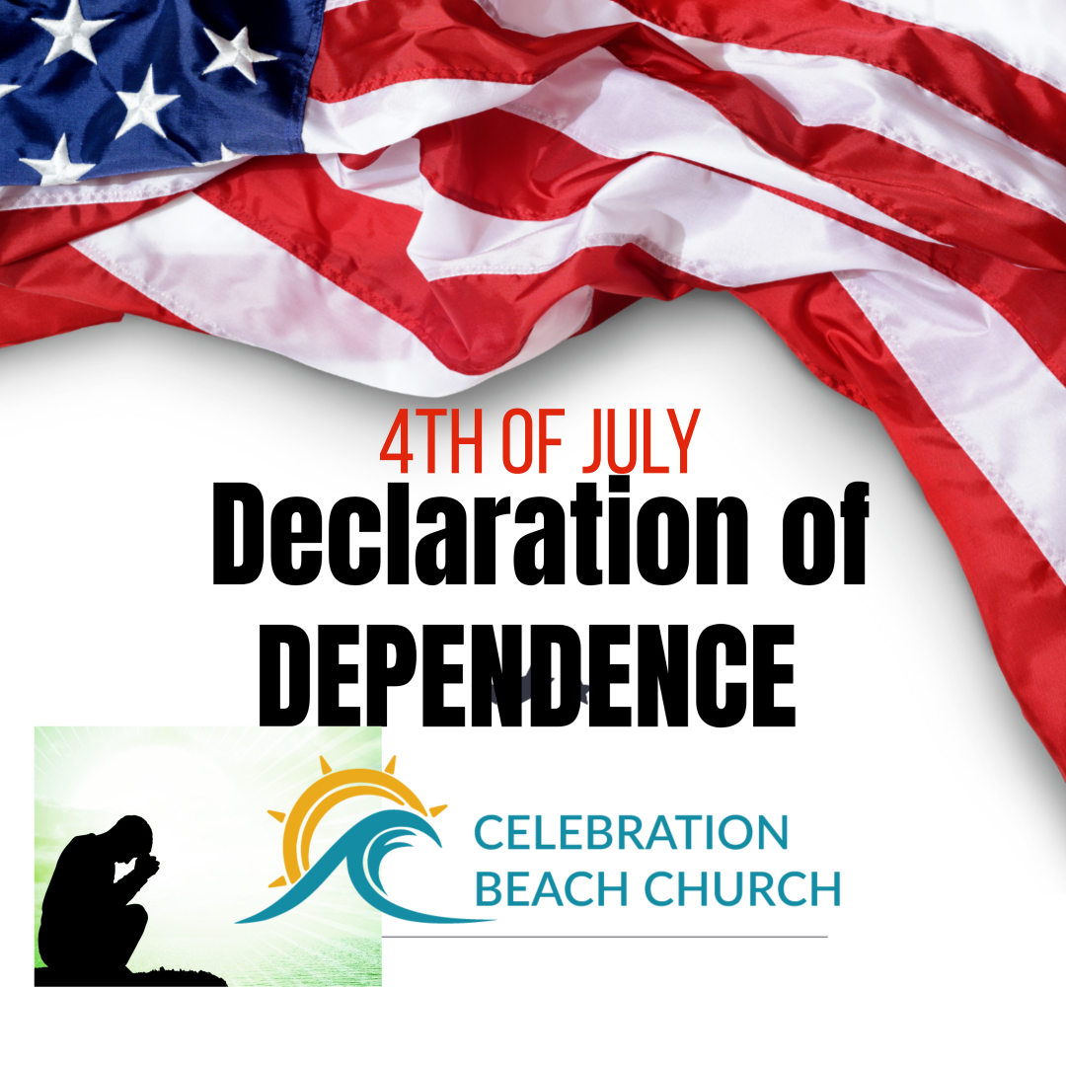
Declaration of DEPENDENCE!
“I lift up my eyes to the mountains— where does my help come from? My help comes from the LORD, the Maker of heaven and earth.” Psalm 12:1-2

1. Declare a DEPENDENCE on God!

“For the Lord your God is bringing you into a good land—a land with brooks, streams, and deep springs gushing out into the valleys and hills;” Deuteronomy 8:7 NIV

“When you have eaten your fill, be sure to praise the Lord your God for the good land He has given you” Deuteronomy 8:10

“We know that God causes everything to work together for the good of those who love God and are called according to his purpose.” Deuteronomy 8:7 NIV

2. Watch out that we don’t forget God!”
¹ Be careful that you do not forget the Lord your God, failing to observe his commands, his laws and his decrees that I am giving you this day. ¹² Otherwise, when you eat and are satisfied, when you build fine houses and settle down, ¹³ and when your herds and flocks grow large and your silver and gold increase and all you have is multiplied, ¹⁴ then your heart will become proud and you will forget the Lord your God, who brought you out of Egypt, out of the land of slavery. Deuteronomy 8:11-14

³ At one time we too were foolish, disobedient, deceived and enslaved by all kinds of passions and pleasures. We lived in malice and envy, being hated and hating one another. Titus 3:3 NIV

- Our REAL Freedom comes from Christ!
¹⁷ Now the Lord is the Spirit, and where the Spirit of the Lord is, there is freedom. 2 Corinthians 3:17 NIV

³⁶ So if the Son sets you free, you will be free indeed John 8:36

¹³ You, my brothers and sisters, were called to be free. But do not use your freedom to indulge the flesh; rather, serve one another humbly in love. ¹⁴ For the entire law is fulfilled in keeping this one command: “Love your neighbor as yourself.” Galatians 5:13-14

